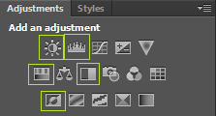
Add these adjustment layers to a photo and tell me what each setting does. Move the sliders left and right to see the effect it has on the photo.
TIP: Delete the adjustment layer before adding a new one

Brightness:

Contrast:

Hue:

Saturation:

Black and White:

Levels:

Invert:

